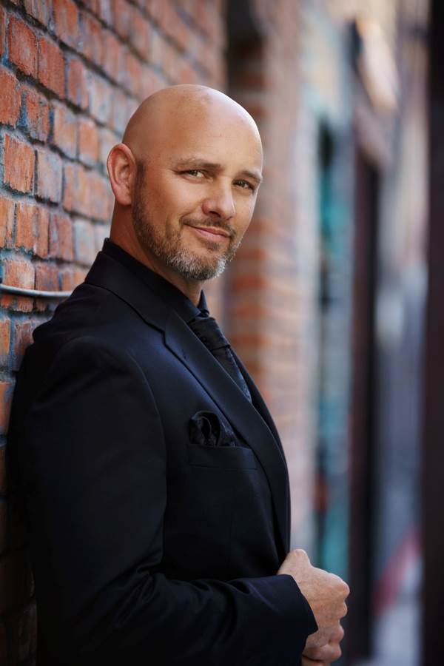
Jason Detwiler
Baritone

Biography

With nearly sixty roles to his credit, Detwiler has become well-known for his magnetic and energizing stage performances. His voice and acting have been described as “emotionally fervid”, “richly expressive”, and “commanding”, garnering acclaim as Eugene Onegin, Conte di Luna (Il trovatore), Zurga (Les pêcheurs de perles), and John Proctor (The Crucible), among others.
His most recent engagements included a return to the Narnia Vocal Arts Festival debuting Aeneas in a double-bill of Dido & Aeneas and the world premiere of Jake Landau’s Aeterna, and as Manon’s Lescaut with Taconic Opera. Upcoming events include Germont
(La traviata) with MidAtlantic Opera, soloist in Handel’s Messiah with Gemma Arts, and a debut of Eisenstein in Mississippi Opera’s spring production of Die Fledermaus.

The baritone has performed nationally and abroad with San Diego Opera,
Virginia Opera, Opéra Théâtre d'Avignon, Wichita Grand Opera, Opera Santa Barbara,
Opera Parallèle, Syracuse Opera, Center for Contemporary Opera, Sacramento Opera, Opéra Louisiane, Shreveport Opera, Festival Opera of Walnut Creek, Opera San Jose, Inland Northwest Opera, Rimrock Opera, West Bay Opera, Vallejo Symphony Orchestra, the American Philharmonic Sonoma County, the Idaho State-Civic Symphony, the Boise Philharmonic and Master Chorale, and the Boise Baroque. Mr. Detwiler has continued to expand his repertory with the musical leads in Rodgers & Hammerstein’s Carousel,
The King & I, Oklahoma!, and South Pacific.

