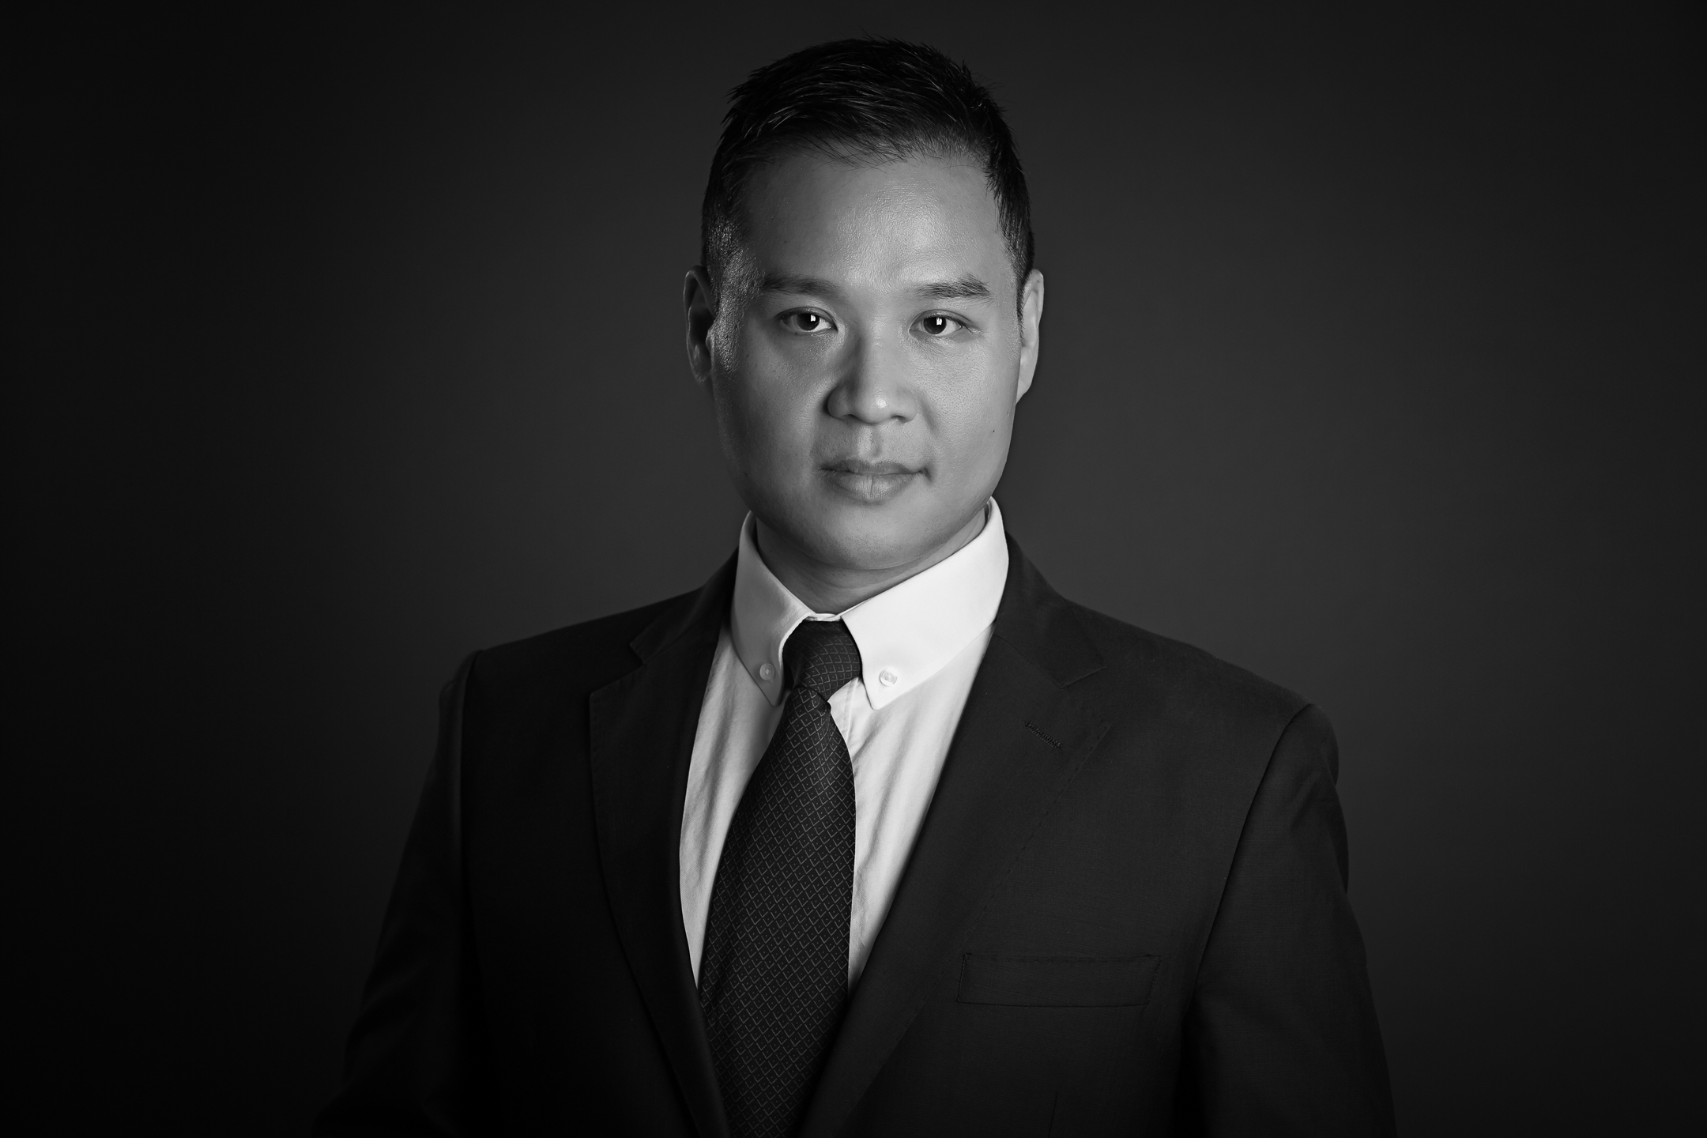
SUCHAN KIM
Baritone

OPERA EXPERIENCE (* Cover)
Zurga* Pearl Fishers Opera in Williamsburg(Williamsburg, VA) 2019
Germont La Traviata New Rochelle Opera(New Rochelle, NY) 2019
Papageno The Magic Flute Opera in Williamsburg(Williamsburg, VA) 2019
Payador María de Buenos Aires Bare Opera (New York City) 2019
Hoël Le Pardon de Ploërmel(Dinorah) Amore Opera (New York City) 2019
Schaunard La Boheme Barn Opera (Brandon, VT) 2018
Marcello La Boheme The New York Concert Opera (New York City) 2018
Barone La Traviata Opera in Williamsburg(Williamsburg, VA) 2018
Germont* La Traviata Opera in Williamsburg(Williamsburg, VA) 2018
Marcello La Boheme New Rochelle Opera (New Rochelle, NY) 2018
Alfonso* La Favorita New Amsterdam Opera (New York City) 2018
Le Dancaïre Carmen Opera in Williamsburg(Williamsburg, VA) 2018
Papageno The Magic Flute(Outreach) Martina Arroyo Foundation (New York City) 2018
Count Figaro/Figaro Bare Opera (New York City) 2017
Fiorello/Ufficiale Il Barbiere di Siviglia Opera in Williamsburg (Williamsburg, VA) 2017
Papageno Die Zauberflöte Bare Opera (New York City) 2017
Count Le Nozze di Figaro Opera in Williamsburg(Williamsburg, VA) 2017
Jailer Dialogues of the Carmelites Sarasota Opera(Sarasota, FL) 2017
Le Marquis de la Force* Dialogues of the Carmelites Sarasota Opera(Sarasota, FL) 2017
Yamadori Madama Butterfly Sarasota Opera(Sarasota, FL) 2017
Yamadori/Bonzo Madama Butterfly New York Opera Collaborative (New York City) 2017
Father Thumbprint Opera Ithaca (Ithaca, NY) 2016
Tobias Mill La cambiale di matrimonio Bare Opera (New York City) 2016
Silvio Pagliacci Dante Hall Theater (Atlantic City, NJ) 2016
Siméon L’Enfant Prodigue The Eutopia Conference/Bare Opera (New York City) 2016
The Critic Rotation NYU IMPACT Conference (New York City) 2016
Dandini La Cenerentola Opera in Williamsburg (Williamsburg,VA) 2016
King Solomon Shulamit Jewish Community Center Manhattan(New York City) 2016
Salieri Mozart and Salieri(Rimsky-Korsakov) Sinfonietta of Riverdale (New York City) 2016
Count Le Nozze di Figaro New York Lyric Opera (New York City) 2015
Paquiro Goyescas Bare Opera (New York City) 2015
Don Giovanni Don Giovanni Opera in Williamsburg (Williamsburg,VA) 2015
Siméon L’Enfant Prodigue Bare Opera (New York City) 2015
the Clock/the Cat L’Enfant et les Sortilèges Bare Opera (New York City) 2015
Enrico Lucia di Lammermoor Opera in Williamsburg (Williamsburg,VA) 2014
Schaunard La Boheme New York Grand Opera (New York City) 2013
Count Le Nozze di Figaro Loft Opera (New York City) 2013
Don Giovanni Don Giovanni Loft Opera (New York City) 2013
Tarquinius The Rape of Lucretia Mannes Opera (New York City) 2013
Germano La Scala di Seta Mannes Opera (New York City) 2012
Don Giovanni Don Giovanni Mannes Opera (New York City) 2012
Fiorello/Ufficiale Il Barbiere di Siviglia Merola Opera Program (San Francisco) 2011
Ford Falstaff Mannes Opera (New York City) 2011
Guglielmo Cosi Fan Tutte Mannes Opera (New York City) 2010
Marullo Rigoletto Seoul Arts Center (Seoul, South Korea) 2008
Enrico Lucia di Lammermoor Piu & Piu Classic Hall (Seoul, South Korea) 2007
Marcello La Boheme Piu & Piu Classic Hall (Seoul, South Korea) 2006
Leporello Don Giovanni The National Theater of Korea (Seoul, South Korea) 2005
Marcello La Boheme Korea National University of Arts (Seoul, South Korea) 2004
Figaro Le Nozze di Figaro Korea National University of Arts (Seoul, South Korea) 2003
Leporello Don Giovanni Korea National University of Arts (Seoul, South Korea) 2001
Sergente La Boheme Korea National University of Arts (Seoul, South Korea) 2000

YOUNG ARTIST / SUMMER PROGRAMS
Studio Artist Participant Sarasota Opera (Sarasota, FL) 2017
New York Summer Opera Scenes Participant New York Summer Opera Scenes (New York City) 2013-15,2017
L’Art du Chant Francais Participant L’Art du Chant Francais (Lanquais, France) 2012
Merola Opera Program Participant San Francisco Opera Center(San Francisco) 2011

AWARDS / COMPETITION
Mannes Opera Award Mannes College The New School for Music 2013
Region-Finalist (Eastern District Winner) Metropolitan Opera National Council Auditions 2011
Scholarship Recipient Mannes College Graduate Division Scholarship 2009-2013

ORATORIO / CONCERT EXPERIENCE
Summer Concert New Rochelle Opera (New Rochelle, NY) 2019
Season Opening Cocnert The Washington Concert Society (Fairfax, VA) 2019
Bass Soloist The Creation Korean Community Christian Singers (Los Angeles, CA) 2019
Baritone Soloist Statue of Liberty Museum Dedication Ceremony (New York City) 2019
Baritone Soloist Fauré Requiem Isaac Stern Auditorium at Carnegie Hall (New York City) 2019
Dinner Concert Opera in Williamsburg(Williamsburg, VA) 2019
Solo Recital Lyric Chamber Music Society of New York (New York City) 2018
Benefit Concert for the North Korean Refugees The New York Art Songs Association (New York City) 2018
Bare Opera Annual Gala Concert Bare Opera (New York City) 2018
Summer Concert New Rochelle Opera(New Rochelle, NY) 2018
Concert Gwangju Culture & Art Center (Gwangju, South Korea) 2018
Guest Singer for Dallas Opera’s Institute for Women Conductors The Juilliard School (New York City) 2018
Preview Concert of La Favorita New Amsterdam Opera (New York City) 2018
Opera’s Great Hits Concert Barn Opera (Brandon, VT) 2018
Bare Opera Concert @ Wellesley College Bare Opera/Wellesley College (Wellesley, MA) 2018
Concert @ Lyric Chamber Music Society of New York Lyric Chamber Music Society of New York (New York City) 2018
Solo Recital Lyric Chamber Music Society of New York/Island Concert Association (St. Simons Island, GA) 2018
Soloist Messe solennelle de sainte Cécil New York Pure Presbyterian Church (New York City) 2017
Concert Ran Baron Auditorium, Israel Conservatory of Music(Tel Aviv, Israel) 2017
Soloist Brahms German Requiem Riverdale Choral Society (Riverdale, NY) 2017
Songs of Travel Sign & Sing (New York City) 2017
Soloist Gala Concert New Amsterdam Opera(New York City) 2016
Solo Recital Lyric Chamber Music Society of New York (New York City) 2016
Soloist The Seven Last words of Christ New York Pure Presbyterian Church (New York City) 2016
Springtime Songs & Arias-Musicale Opera at Florham (New Jersey) 2016
Soloist Brahms German Requiem Rockland County Choral Society (Suffern, NY) 2015
Count Almaviva New York Lyric Opera Gala Concert Weill Recital Hall at Carnegie Hall (New York City) 2014
Soloist Brahms German Requiem Fairfield County Chorale (Norwalk,CT) 2013
Eugene Onegin Merola Schwabacher Concert Herbst Theater (San Francisco) 2011
Yeletski, Taddeo Merola Grand Finale War Memorial House (San Francisco) 2011

EDUCATION HISTORY
Master of Music Mannes College The New School for Music 2013
Professional Studies Diploma Mannes College The New School for Music 2011
Bachelor of Music Korea National University of Arts 2005

FUTURE ENGAGEMENT
Soloist Gala Concert Teatro Grattacielo (New York City) 2019
Don Giovanni Don Giovanni Bare Opera (New York City) 2019
Concert Island Concert Association (St. Simons Island, GA) 2020
Solo Recital Jamestown Concert Association (Jamestown, NY) 2020
Marcello La Boheme Opera in Williamsburg (Williamsburg, VA) 2020

